OPERATING SYSTEMS LAB

Laboratory 5

Ashwin Waghmare 210010060

Part 1
Minix Scheduling
- Workload Mix 1: Completely CPU intensive
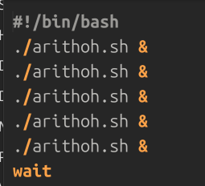

This workload contains five instances of arithoh.sh making it completely CPU intensive. We can observe the Round Robin nature of scheduling as processes are being swapped in a repeated manner. The time quantum of 200 is fully utilized in each burst thus proving it is CPU intensive.
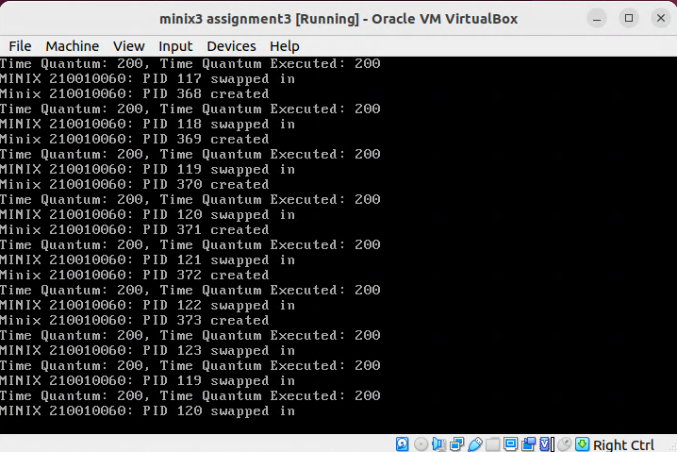
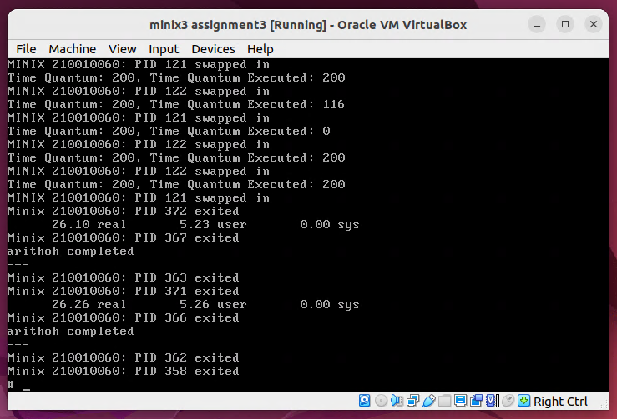
- Workload Mix 2: Completely IO intensive
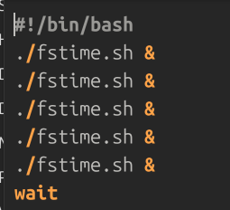

This workload contains five instances of fstime.sh making it completely IO intensive. These five processes also run in Round Robin manner. Also we can see that the burst is not fully utilized proving it is IO intensive.
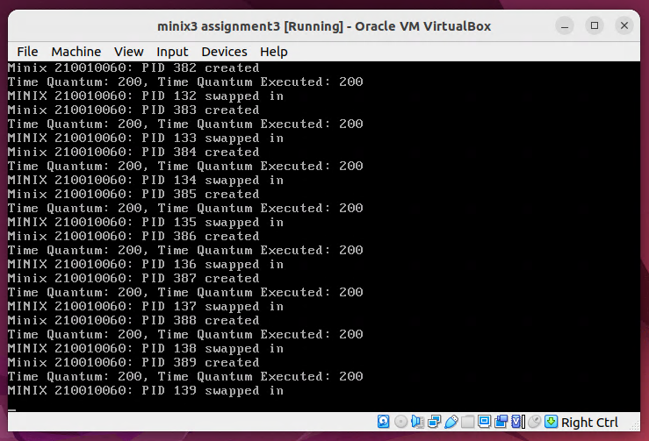

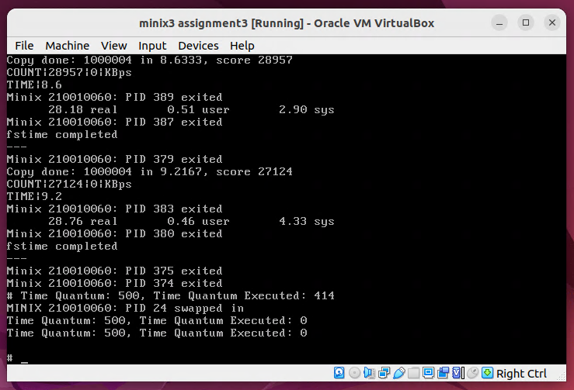
- Workload Mix 3: Completely System Call intensive
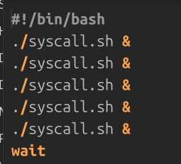

This workload contains five instances of syscall.sh making it a fully system call intensive workload. These five processes also run in Round Robin manner. Here, the time quanta is not always fully utilized.
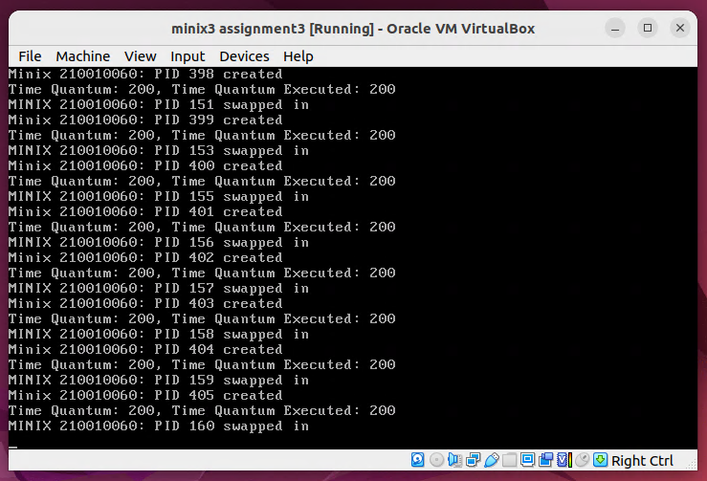
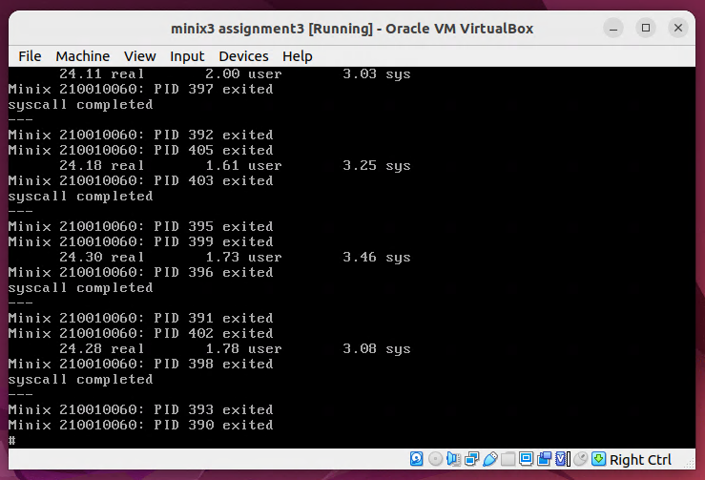

- Workload Mix 4: Mixed workload
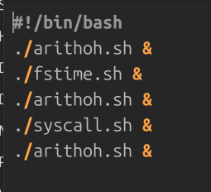

This workload contains three instances of arithoh.sh, one fstime.sh and one syscall.sh. We can observe that syscall completes execution first, followed by fstime and finally the three arithoh. Also we can see that fstime is sometimes allotted a longer burst and is not fully utilized as it is IO intensive. Once fstime and syscall are done, the three arithoh run in Round Robin manner.

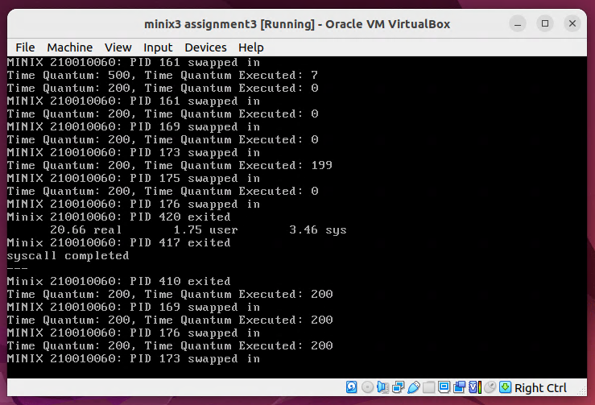
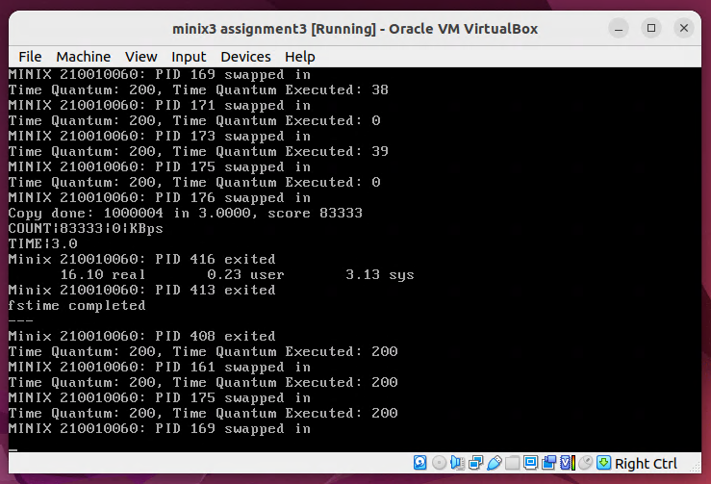

Part 2
Pseudo FIFO implementation
To modify the user-level scheduler in Minix3 to the “Pseudo-FIFO” policy: among the user-level processes that are ready to execute, the one that entered the earliest must be scheduled. The following changes are made in minix/servers/sched/schedule.c in do_quantum()
rmp→priority += 1 was changed to rmp→priority -= 1
This allows FIFO to occur by lowering the priority value, preventing the incoming processes to pre-emptively get time slices for execution.
In this same file line:
rmp→priority -= 1
was removed in the function balance_queues() to prevent overflow of priority queues.

Workload mixes
- Workload Mix 1: Completely CPU intensive
Here we observe that arithoh processes run sequentially, ie they exit in the order they arrive. This is in contrast to the earlier scheduler.

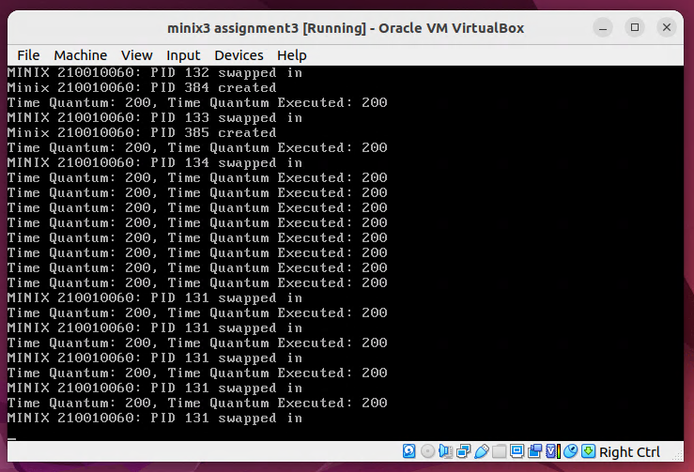
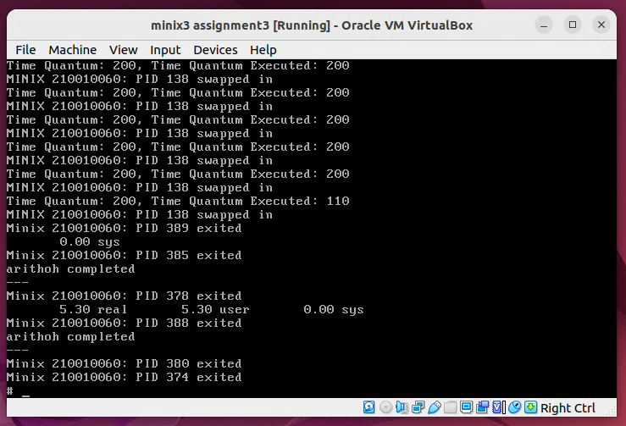

- Workload Mix 2: Completely IO intensive
In this workload mix we took 5 fstime.sh continuously, according to First In First Out scheduling algorithm the 5 processes should be exited in order of their arrival but from the output we can see that FIFO is not happening properly, making this scheduling process Pseudo FIFO. This is because fstime.sh is I/O bound process which goes to blocked state waiting for response, in the meanwhile the next process is scheduled and this whole results in round robin scheduling. So, there is no difference in output for original minix shedular and Pseudo FIFO for this workload mix.

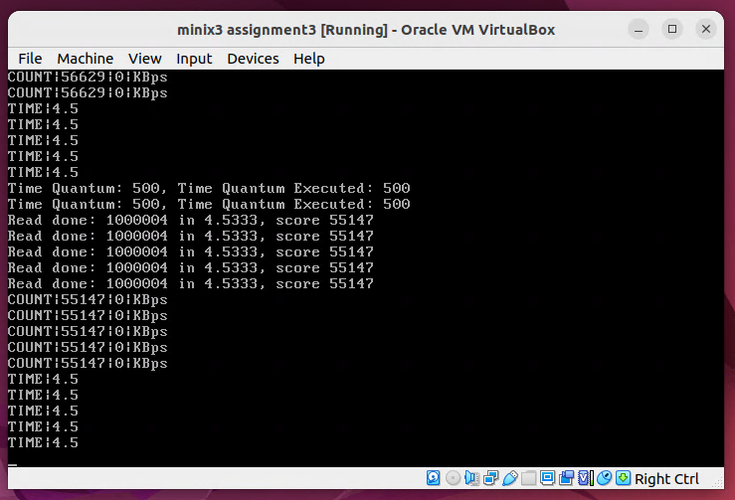
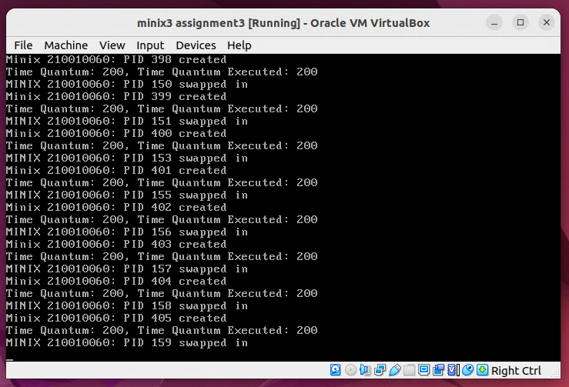

- Workload Mix 3: Completely System call intensive
The execution of this workload script is quite similar to that of the arithoh-based CPU-intensive script. This is because syscall is effectively a CPU-intensive process, though not as intensive as arithoh. Note that syscall process uses the full CPU burst a lot of the time, and doesn’t end up in the round-robin that I/O processes end up doing. Hence, Pseudo-FIFO behaviour has been observed in the scheduling policy after we made modifications to the source code of Minix3, as mentioned at the beginning of the section.

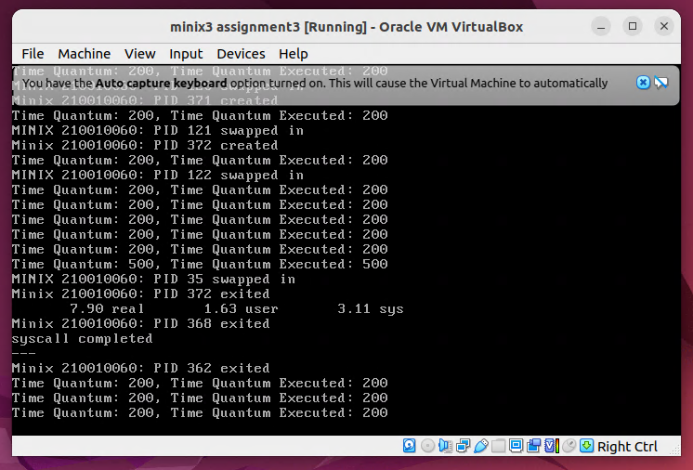

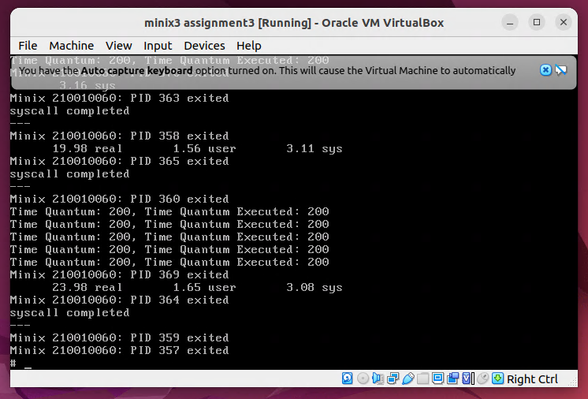

- Workload Mix 4: Mixed workload

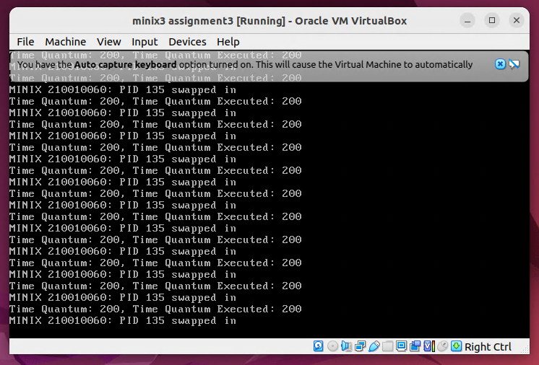

We can observe that the processes are being executed in such an order that the CPU takes up the CPU-intensive processes at first, which is a set of arithoh.sh processes running at the same time. This is because the I/O-intensive processes get blocked after requesting for I/O. Of course, we do have syscall.sh which is a CPU-intensive process as well, but it is not as intensive as arithoh.

